**Analysis of Airport Data using Hadoop-Hive**

1. **creating table airport for airports_mod.dat**:

create table airports (airport_id int,airport_name string,airport_city string,airport_country string,airport_faa string,airport_icao string,airport_lat double,airport_long double,airport_alt double,airport_timezone double,airport_dst string,airport_tz string) row format delimited fields terminated by ',';



2.**creating table finalairlines for Final_airlines** :

create table final_airlines (airlineID string,airline_name string, airline_alias string, airline_iata string, airline_icao string,callsign string,territory string, active string) row format delimited fields terminated by ',';



3. **Creating table route for routes.dat**:

create table routes (route_iata string,route_airid int,route_source_iata string,route_source_airid int,route_des_iata string,route_des_airid int,route_codeshare string,route_stops int,route_equip string) row format delimited fields terminated by ',';



4. **loading data into airport table**

load data inpath 'data/Air-datasets/airports_mod.dat' into table airports;

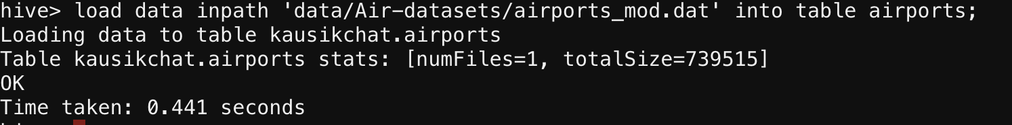

5. **loading data into final airlines table**

load data inpath 'data/Air-datasets/Final_airlines' into table final_airlines;



6**.loading data into route table**

load data inpath 'data/Air-datasets/routes.dat' into table routes;



**Problem solution**:

a) **Find list of Airports operating in the Country India**;

create table india_opert_airport as select * from airports where airport_country LIKE '%India%';

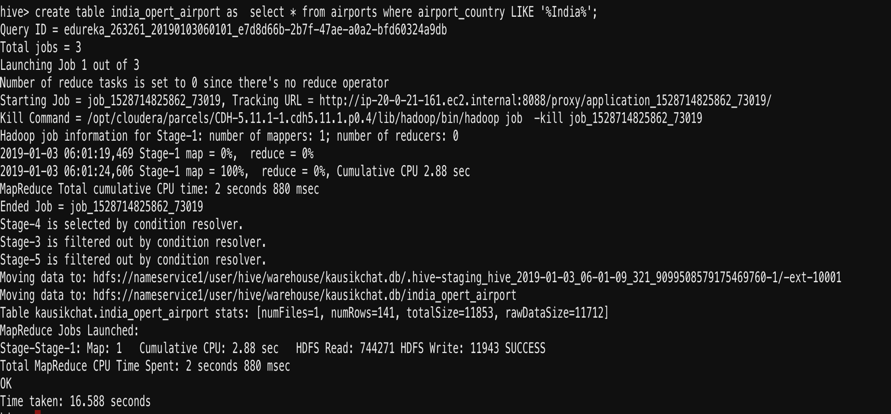

select * from india_opert_airport limit 10; (to show only first 10 values due to large nos of data)

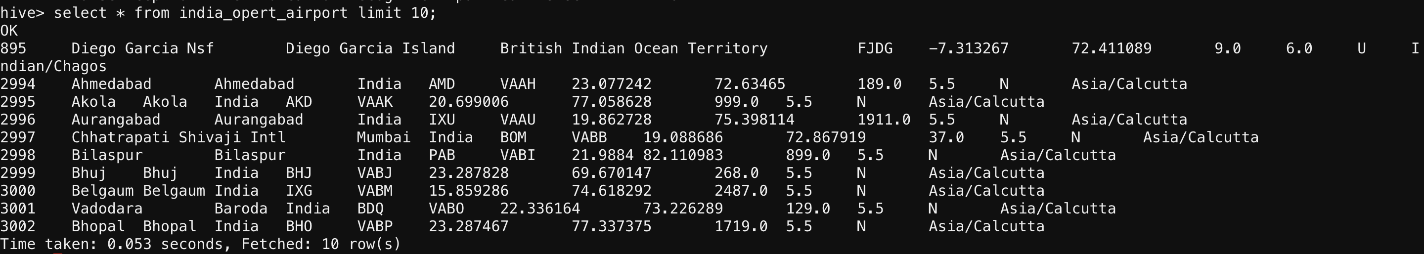

b.**Find the list of Airlines having zero stops**

create table stop as select * from route where route_stops LIKE '%0';

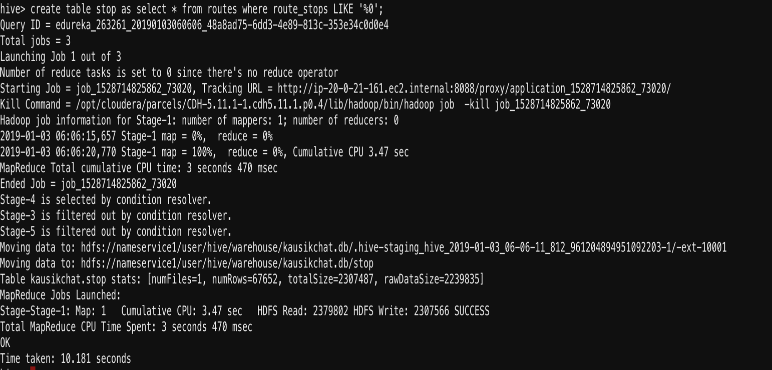

select * from stop limit 10;

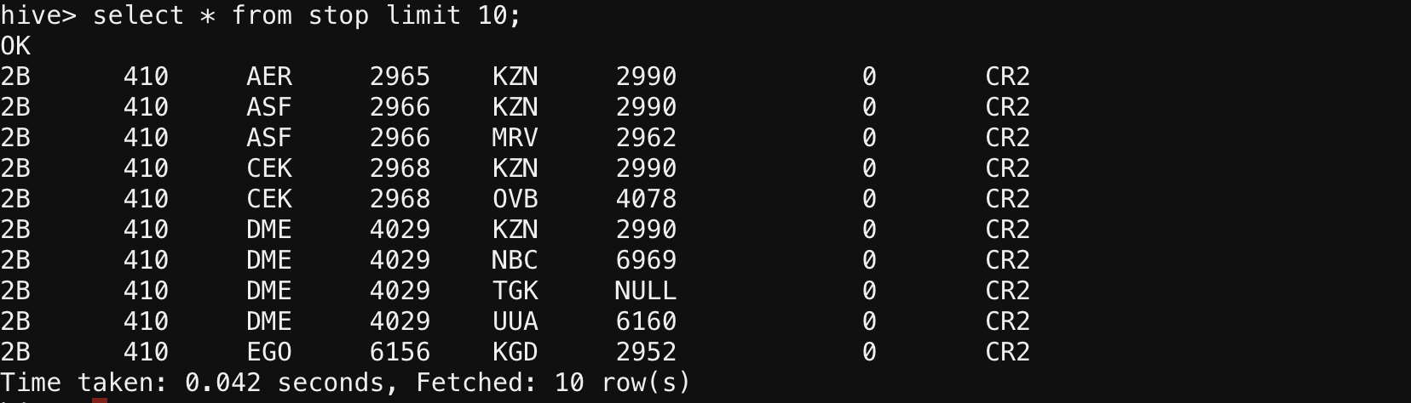

**c. List of Airlines operating with code share**

create table codeshare_1 as select * from routes where routes_codeshare LIKE '%Y%';

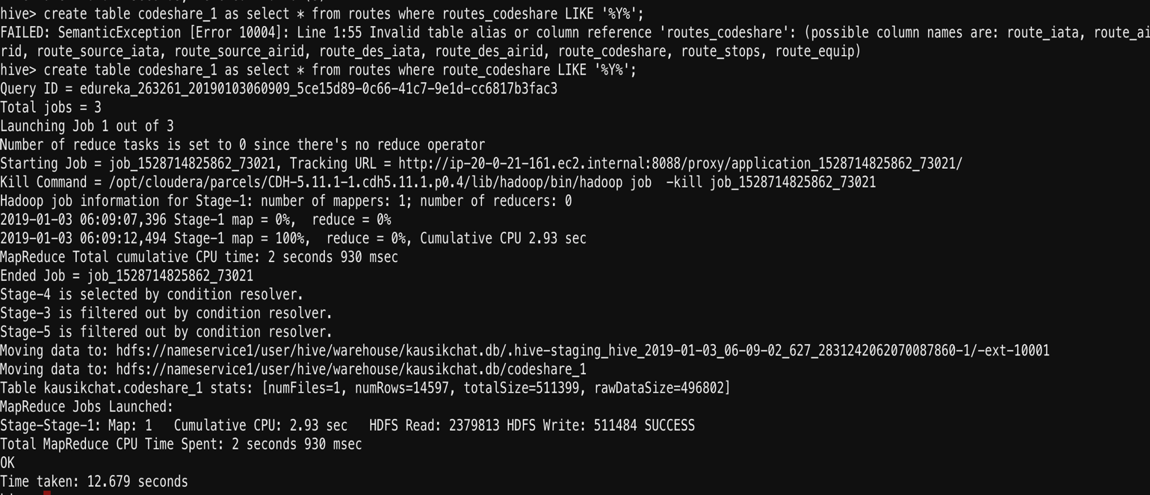

select * from codeshare_1 limit 10;

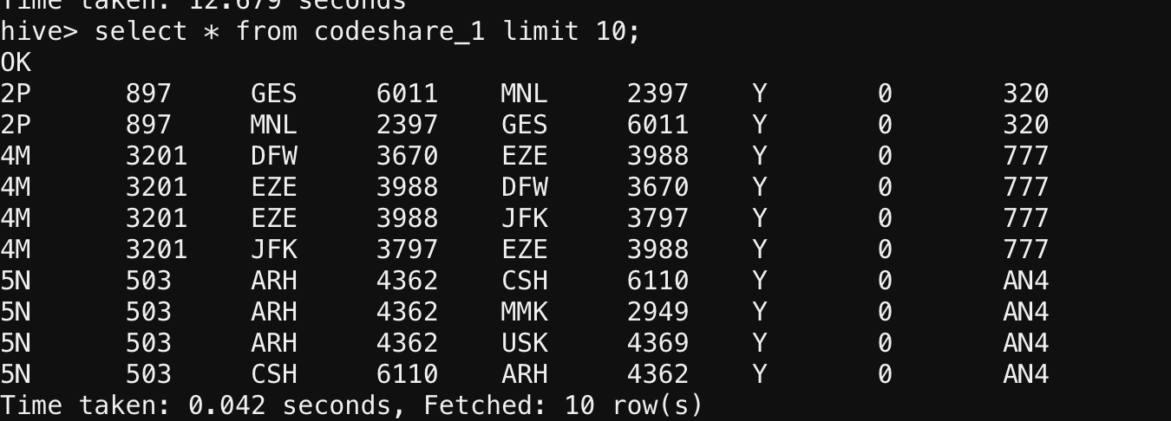

**d. Which country (or) territory having highest Airports**

select airport_country,count(*) as cnt from airports group by airport_country ORDER BY cnt DESC;

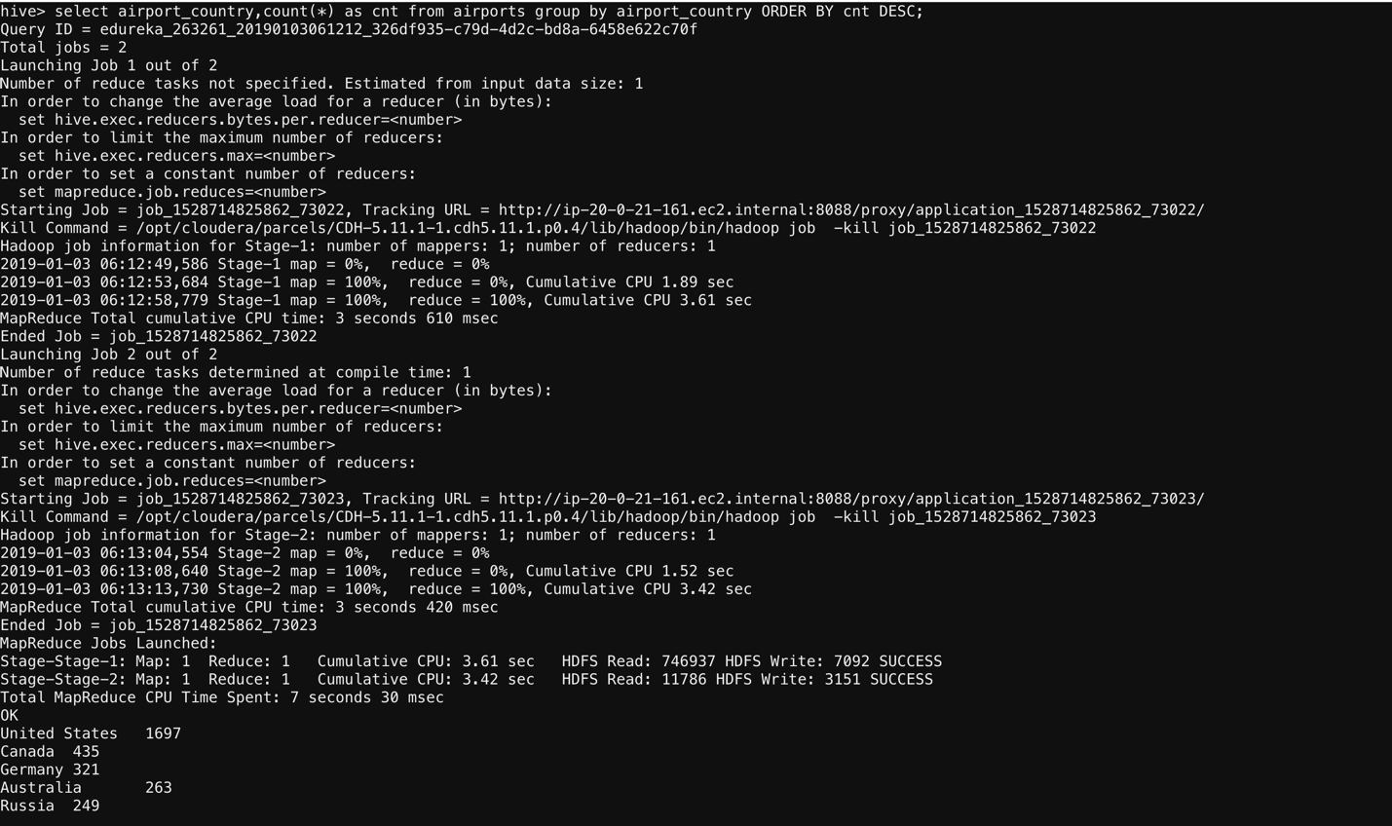

**E. Find the list of Active Airlines in United state**

select * from final_airlines where territory like '%United States%' AND active like '%Y%';

